Contents

**Introduction** 1

How to run? 1

1. Background Subtraction 2

a) Codebooks construction from N frames 2

b) Refined codebooks by employing the maximum negative run length 5

c) Foreground detection to get the foreground pixels 6

searchCodeBook matlab code 7

2. Morphological Operations 9

a) Matlab Code for Morphological Operation 9

b) First Dilation and then erosion 9

c) Result Frames 9

3. Connected Components Labeling 12

**Introduction**

1. Bgsubtraction.m = main .m file implementing the “Background Modeling and subtraction by codebook costruction” by Kyungnam Kim, Thanarat H. Chalidabhongse, David Harwood, Larry Davis.
2. codebook_video1_1.mat = it is code book generated for all the frames present in the video1_1 folder.

## How to run?

>> bgsubtraction(<Path of test sequence>',0.5,1.3,20,22,0,1)

Parameter 1 = path of the folder containing i) training image if generating codewords ii) test images if obtaining the foreground using algorithm.

Parameter 2: alpha value

Parameter 3: beta value

Parameter 4: epsilon1

Parameter 5: epsilon2

Parameter 6: 1 if generating code book else 0

Parameter 7: 1 if detecting the foreground else 0

1. Background Subtraction
2. Codebooks construction from N frames

Matlab Code:

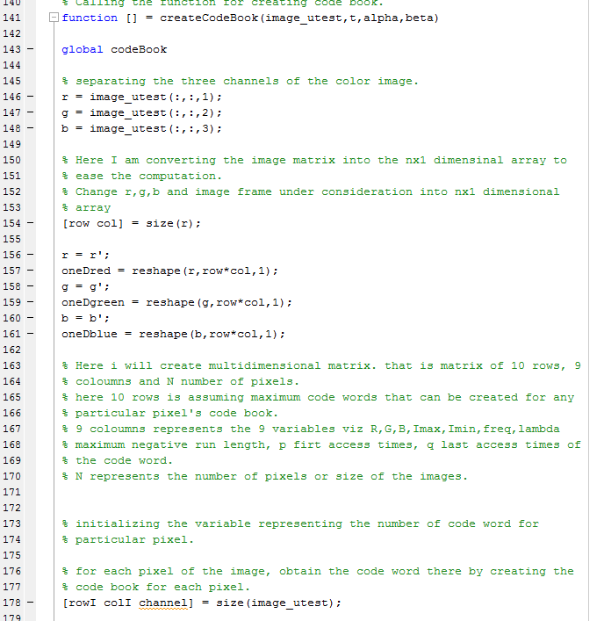

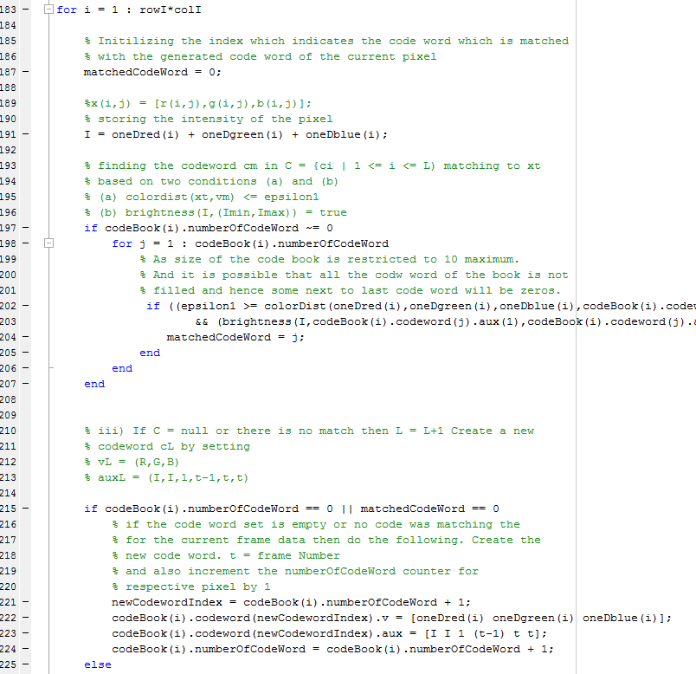

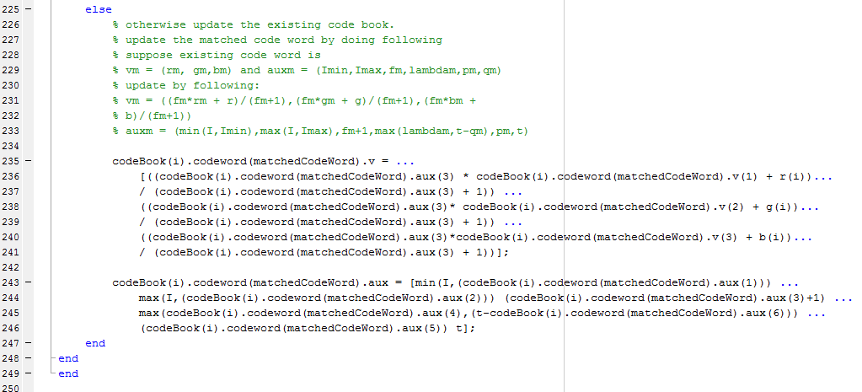

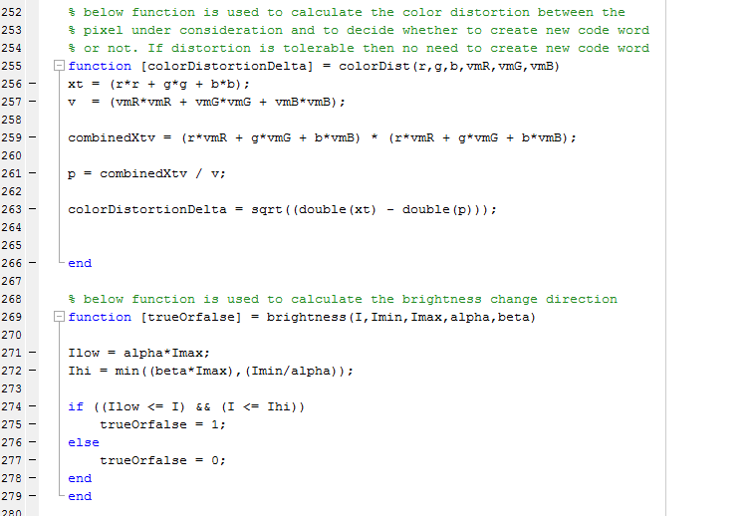

1. Refined codebooks by employing the maximum negative run length

Matlab Code:

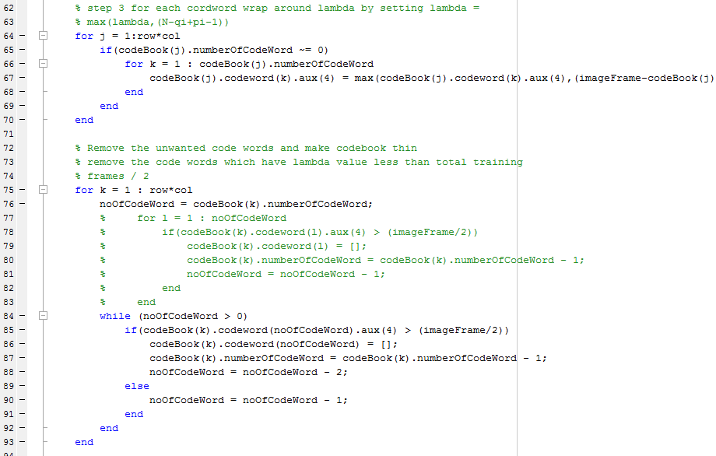

1. Foreground detection to get the foreground pixels

Matlab Code:

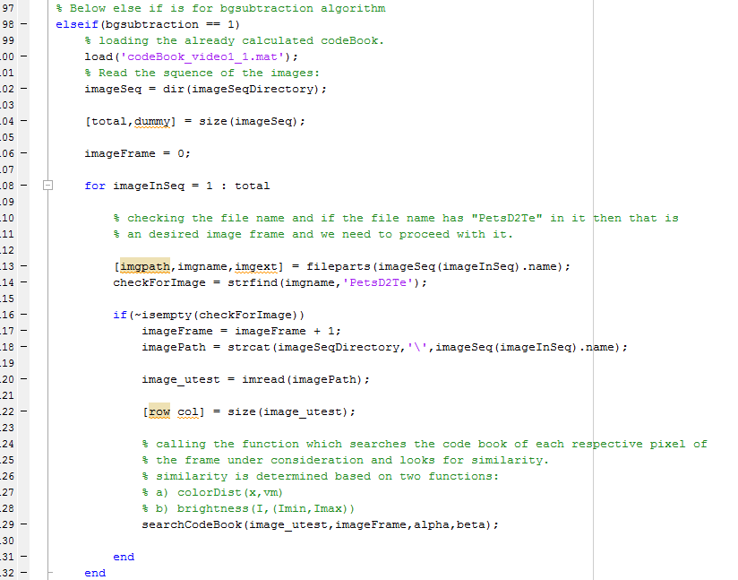

searchCodeBook matlab code

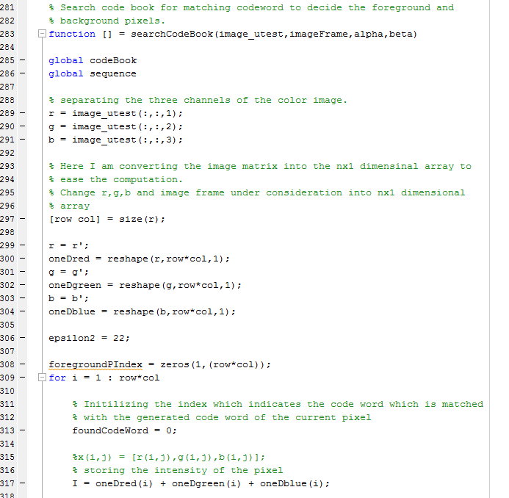

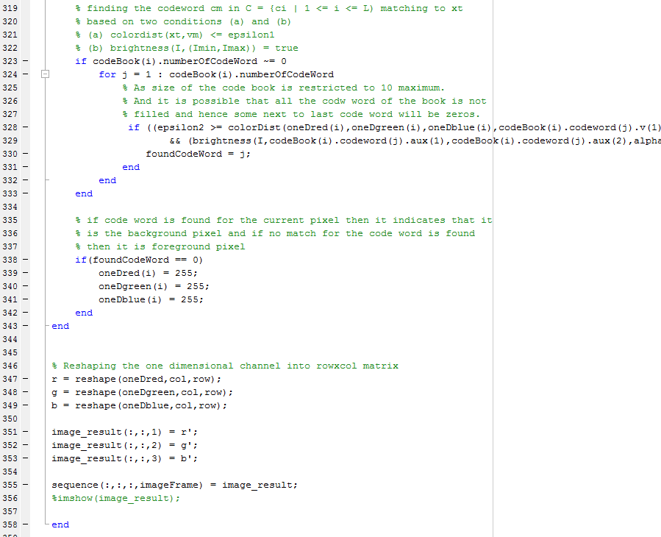

1. Morphological Operations
2. Matlab Code for Morphological Operation

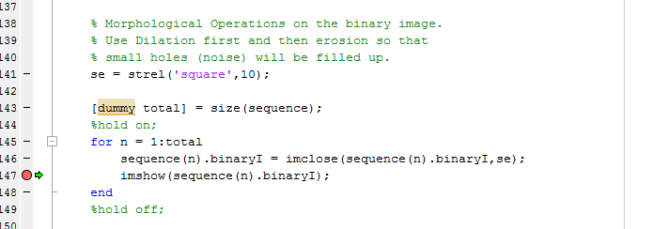

1. First Dilation and then erosion

I am using dilation first then followed by erosion so as to fill up the small holes in the image.

1. Result Frames

Frame 1:

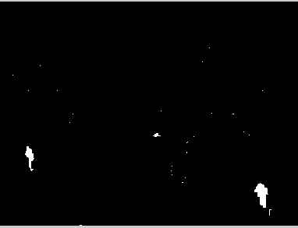

Frame 2:

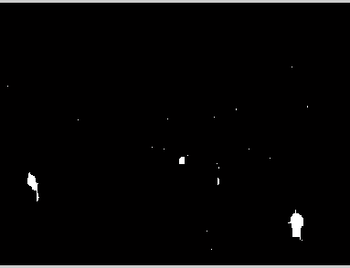

Frame 3:

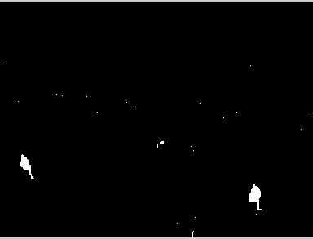

Frame 4:

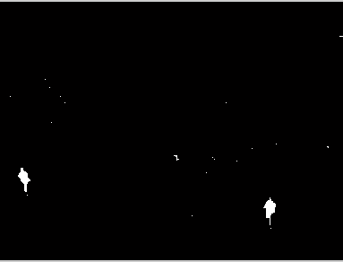

Frame 5:

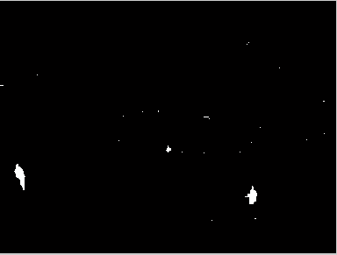

1. Connected Components Labeling

I used the following connected component algorithm:

Matlab Code:

